|  |  |
| --- | --- |
| Date | 25 June 2025 |
| Team ID | LTVIP2025TMID20412 |
| Project Name | Calculating Family Expenses using Service Now |
| Mentor Name | Dr Shaik Salma Begum |
| Maximum Marks | 10 Marks |

# **Calculating Family Expenses using Service Now**

**Milestone 1: Setting Up ServiceNow Instance:**

* Sign up on [developer.servicenow.com](https://developer.servicenow.com) and create a developer account.
* Navigate to the Personal Developer Instance section and request a new instance.
* Fill out the required information and submit the request.
* Instance details (URL, username, password) will be sent via email.
* Log in to the instance using the provided credentials.
* The instance is ready for development and customization.

**Milestone 2: Creation of New Update Set:**

* Creating a Local Update Set in ServiceNow
  + Navigate to All in the application navigator.
  + In the filter search bar, type Local Update Set and select it from the results.
  + Click on the New button to create a new update set.
    - Name: Family Expenses
  + In the form that appears, enter the following details:
  + Click on Submit to save the update set.
  + After submission, click on Make Current to set this update set as the active one.
* Then created update set called “Family Expenses” and made it current

**Milestone 3: Creation of Table (Family Expenses):**

* Creation of Family Expenses tables and its fields:

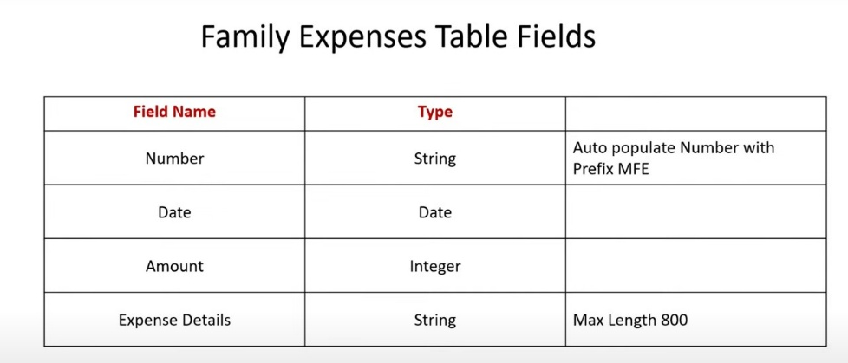

* + Navigate to **All** in the application navigator.
  + In the filter search bar, type **Tables** and select it from the results.
  + Click on the **New** button to create a new table.
  + In the form, provide the following details:
    - **Label**: Family Expenses
    - **Name**: Auto-Populated(automatically generated based on the label)
    - **New menu name**: Family Expenditure
  + Navigate to the header section of the form, right-click on the header, and select **Save** from the context menu.

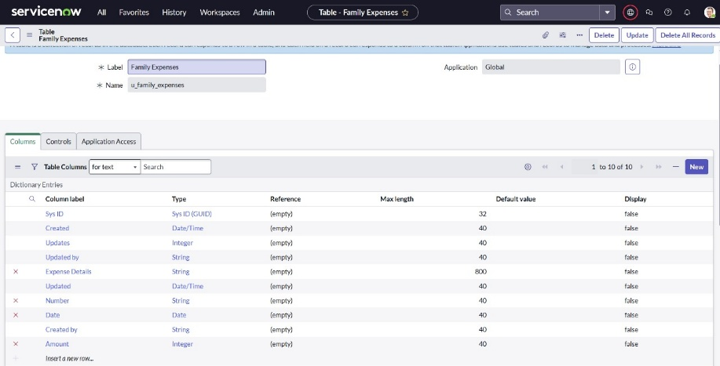

* Making Number Field an Auto-Number:
  + In the Columns section of the *Family Expenses* table, locate and double-click on the Number field to open its configuration.
  + Scroll down and double-click on Advanced view to expand additional settings.
  + Under the Default Value section:
  + Enable the checkbox for Use dynamic default.
  + Set the Dynamic default value to Get Next Padded Number.
  + Click on Update to save the changes to the field.

* Setting Up Number Maintenance for the Family Expenses Table
  + Navigate to All in the application navigator.
  + In the filter search bar, type Number Maintenance and select it from the list.
  + Click on the New button to create a new number maintenance record.
  + Provide the following details:
    - Table: Family Expenses
    - Prefix: MFE
  + Click on Submit to save the configuration.

* Configure the Form:
  + Navigate to All in the application navigator.
  + In the filter search bar, type Family Expenses and select it from the results to open the module.
  + Click on the New button to open a new record form.
  + In the form header, right-click and select Configure > Form Design from the dropdown menu.
  + In the Form Designer, use drag-and-drop functionality to customize the layout of the form fields as needed. Fields can be rearranged, moved between sections, or grouped based on specific requirements.
  + Once the desired layout has been achieved, click Save or Close to apply the changes.
    - Before Form design:

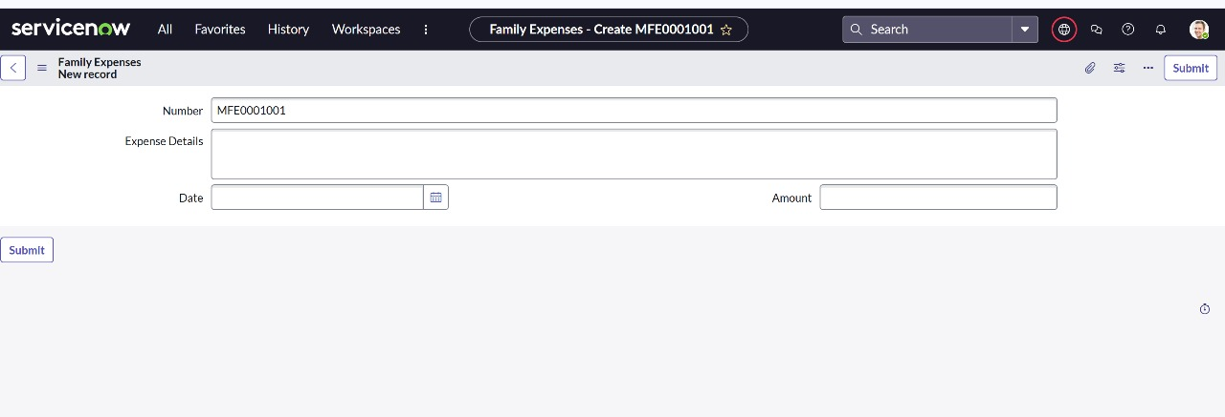

* + - Form design:

* + - After form design:

**Milestone 4: Creation of Table (Daily Expenses):**

* Creation of Daily Expenses Table and its fields:

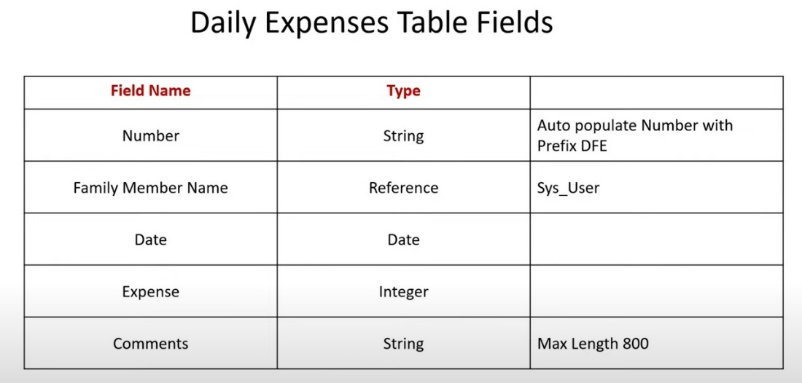

* + Navigate to All in the application navigator.
  + In the filter search bar, type Tables and select it from the list.
  + Click on the New button to create a new table.
  + Fill in the following details in the form:
    - Label: Daily Expenses
    - Name: Auto-Populated (automatically generated based on the label)
    - Add Module to menu: Family Expenditure
  + Navigate to the header of the form, right-click, and select Save from the context menu.

* Making Number Field an Auto-Number:
  + In the Columns section of the Daily Expenses table, locate and double-click on the Number field to open its configuration.
  + Scroll down and double-click on Advanced view to expand additional settings.
  + Under the Default Value section:
  + Enable the checkbox for Use dynamic default.
  + Set the Dynamic default value to Get Next Padded Number.
  + Click on Update to save the changes to the field.

* Setting Up Number Maintenance for the Daily Expenses Table
  + Navigate to All in the application navigator.
  + In the filter search bar, type Number Maintenance and select it from the list.
  + Click on the New button to create a new number maintenance record.
  + Provide the following details:
    - Table: Daily Expenses
    - Prefix: DFE
  + Click on Submit to save the configuration.

* Configure the Form:
  + Navigate to All in the application navigator.
  + In the filter search bar, type Daily Expenses and select it from the results to open the module.
  + Click on the New button to open a new record form.
  + In the form header, right-click and select Configure > Form Design from the dropdown menu.
  + In the Form Designer, use drag-and-drop functionality to customize the layout of the form fields as needed. Fields can be rearranged, moved between sections, or grouped based on specific requirements.
  + Once the desired layout has been achieved, click Save or Close to apply the changes.
    - Before Form design:

* + - Form design:

* + - After form design:

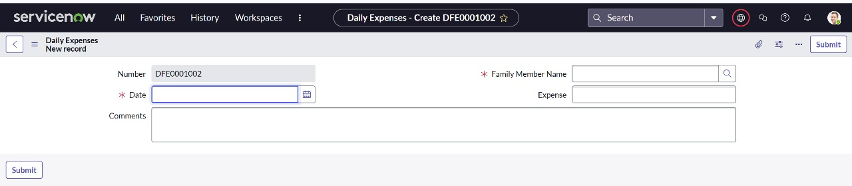

**Milestone 5: Creation of Relationship:**

* Creation of Relationship between Family Expenses and Daily Expenses tables
  + Navigate to All in the application navigator.
  + In the filter search bar, type Relationships and select it from the list.
  + Click on the New button to create a new relationship.
  + Enter the following details:
    - Name: Daily Expenses
    - Applies to Table: Family Expenses
    - Queries to Table: Daily Expenses
* Click Save to store the relationship.

**Milestone 6: Configuring Related List on Family Expenses:**

* + Navigate to All in the main menu.
  + In the filter/search bar, type Family Expenses, then select and open the Family Expenses module.
  + Click on the New button to create a new Family Expenses record.
  + In the header section of the screen, right-click and choose Configure from the context menu.
  + From the configuration options, select Related Lists.
  + In the Related Lists configuration screen, locate Daily Expenses in the available list.
  + Move Daily Expenses to the Selected area to include it in the related lists for Family Expenses.
  + Click Save or Done (depending on the interface) to apply the changes.

**Milestone 7: Creation of Business Rules:**

* + From the main navigation, go to All.
  + In the search or filter bar, type Business Rules.
  + Under the System Definition section, click on Business Rules.
  + Click on the New button to create a new business rule.
  + Fill in the Business Rule Details:
    - Name: Family Expenses BR
    - Table: Select Daily Expenses from the dropdown list.
  + Check the box labeled Advanced to enable additional configuration options.
  + Configure When to Run: Under the When to Run section, make sure the following options are checked:
    - Insert
    - Update

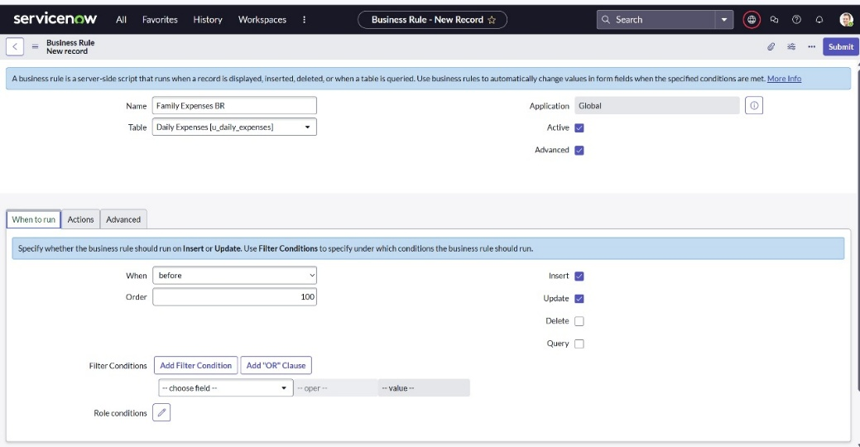

* + In Advance (write the code): Write the below code >>

**Milestone 8: Configure the Relationship:**

* From the main navigation, go to All.
* In the search bar, type Relationships, then open the Relationships module.
* Locate and open the Daily Expenses Relationship record.
* Set the Following Details:
  + For Applies to table, select Family Expenses from the dropdown list.
* **A**fter entering the script, click Update to save your changes**.**

